**GTRERP Modules :**  
  
Quiz Module:

The action method for making quiz is in the TutorialCertificateController.  
One can create,edit and delete quiz. Then examinee will get all the quiz from QuizExamPage  
controller.  
  
The whole quiz module is consists of 10 action method

* public IActionResult quizList(): used to redirect to the created quiz list  
    
  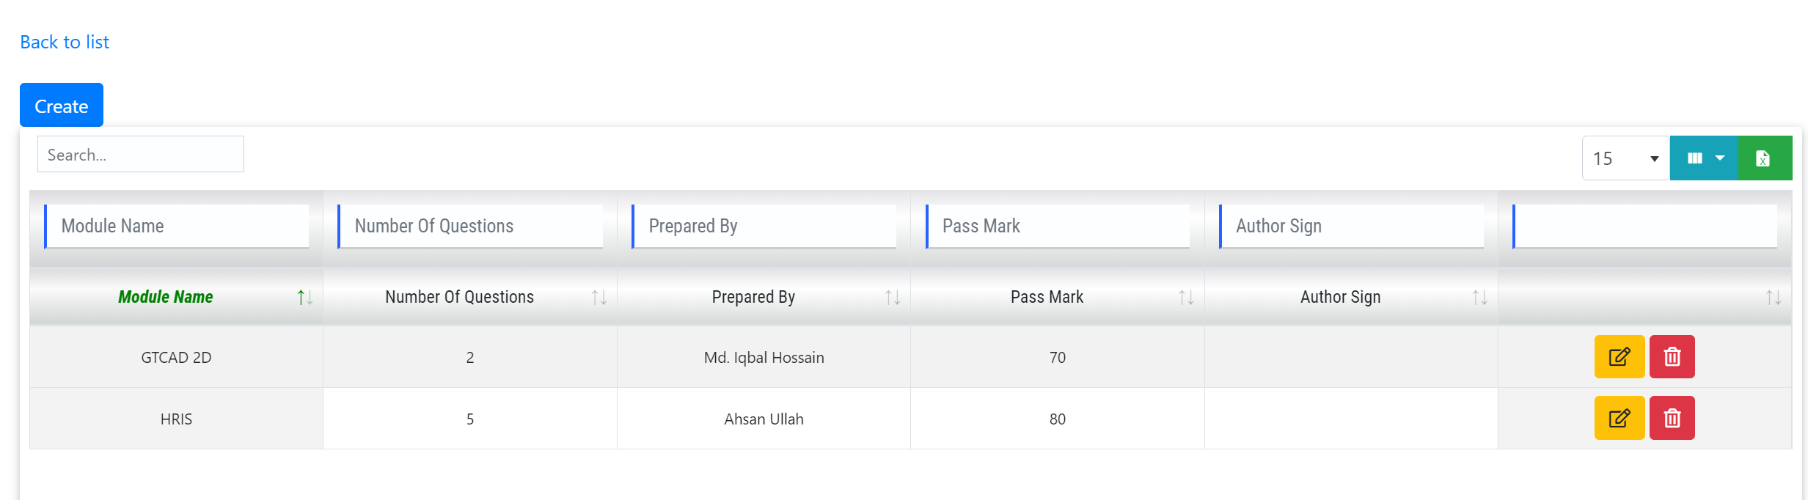
* public IActionResult Quiz(): It’s a method to view the quiz creation page. This is worked by “create” button of the list  
    
  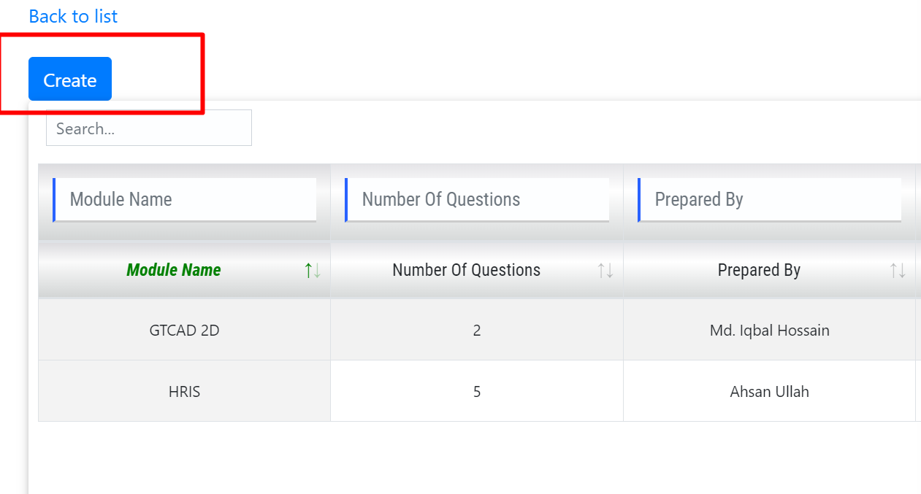

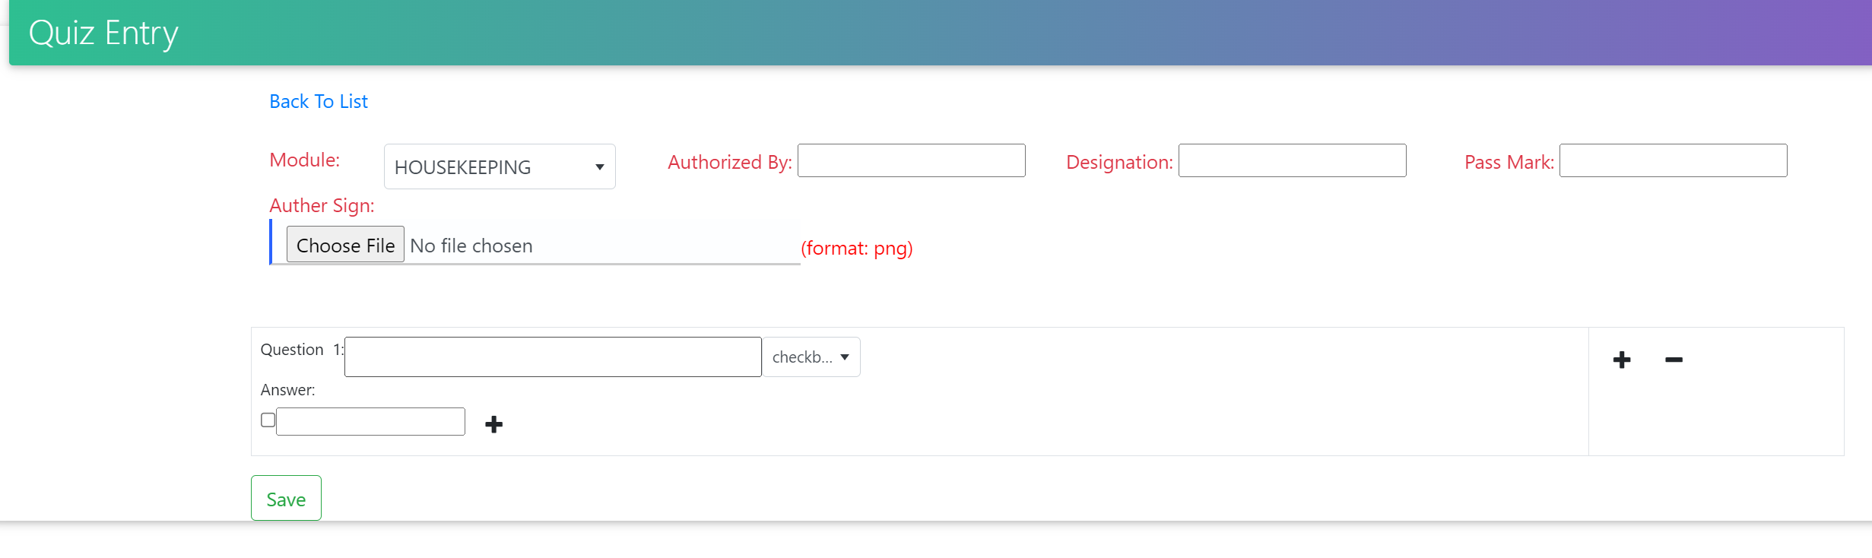

* public IActionResult SaveQuiz(string ques, IFormFile file): this is for saving quiz.
* private string UploadFiles(IFormFile file, string title): Uplaod sign or any other file
* public IActionResult EditQuiz(int moduleid): Post maethod for edit quiz.
* public IActionResult DeleteQuiz(int moduleid): it is used to delete whole quiz set from list.
* public IActionResult DeleteQues(int quesNo): it used to delete single question.
* public IActionResult QuizExamPage(int moduleId, string msg): Q/A page for the examinee.
* public IActionResult CheckQuiz(List<quizAnsVm> QuizAns)”: Post method to check correct answer after submitting the answer.
* public IActionResult CheckCertificate(string id): Used to verify certificate.